**A**

**Report**

**On**

**Students Seminar**

**(5th March, 2024)**

**Department of Defence Studies**

**Rabindra Mahavidyalaya,Champadanga**

**Theme: *Science and Technology and Defence***

**Venue: Room No. 67 (Department of Defence Studies)**

**Date: 5th March, 2024**

**Organizer: Department of Defence Studies**

**Category of the Seminar: Departmental**

**Paper Presenters: Students of Semester – I & IV (General)**

**Total No. of Participants: 43 Students (Including paper presenters)**

**Objective**:

* To gain knowledge about Science and Technology and Defence
* To provide an opportunity for participants to gain knowledge and skill through lectures, discussion and interactive activities.
* To provide a comprehensive overview of a particular topic
* To provide in depth training on a specific subject.
* To grow presentation skills.

**Highlights**: A Departmental Seminar was organized on 5th March, 2024 by the Department of Defence Studies. The Seminar held in the Department of Defence Studies room no. 67. Forty three participants attend in the seminar (as a part of Science Week Celebration). Prof. Dipankar Jana hosted the seminar and he welcomed all participants. In his inaugural speech he discussed the necessities to know why a country (India) Dependence on science and technology for Defence and security. All technical session were chaired by the departmental faculty. Prof.Dipankar Jana acts as judge and Prof. Srikanta Adhikari monitored the whole session. All the sessions were very interactive where pupils have been quite enthusiastic and all of their questions have been satisfactorily answered. Finally, the seminar ends with a grand success and vote of thanks was given by Prof. Srikanta Adhikari.

The Department would also take the opportunity to convey it’s thanks to the college administration for their support.

Additionally, a manual feedback form was created and circulated to the students guardians for their valuable feedback. The feedback received was extremely positive.

**Outcome of the Seminar**:

**This topic is included in the CBCS syllabus as well as in the previous 3years degree course. All the participants including students are also benefitted through getting an overall idea in the discussion. Many of the courageous participants express their expectation for arranging more seminars in future. This seminar will be helpful to all participants.**

**STUDENT’S SEMINAR**

***Theme: Science and Technology and Defence***

**Date: 5h March, 2024**

**Venue: Department of Defence Studies, Rabindra Mahavidyalaya,Champadanga**

**Time: 12:00 to 3:00 pm**

* **Inauguration**
* **Principal’s speech**
* **Technical session-1: 12:30 to 1:15 pm**
* **Chairman: Dipankar Jana**
* **Rapporteur: Srikanta Adhikari**
* **Paper: Tejas and Defence**
* **Paper: Indian Air Defence Technology**
* **Technical Session-2: 1:30 to 3:00 pm**
* **Chairman: Srikanta Adhikari**
* **Rapporteur: Dipankar Jana**
* **Paper: Science and Technology and Defence**
* **Paper: Technology and Navy**
* **Prize distribution**
* **Vote of Thanks: Srikanta Adhikari**

**STUDENT’S SEMINAR**

***Theme: Science and Technology and Defence***

**Date: 5th March, 2024**

**Venue: Department of Defence Studies, Rabindra Mahavidyalaya,Champadanga**

**Time: 12:00 to 03:00 pm**

* **Paper: Tejas and Defence**
* **Presenters: SrijanBhowmik, KoyelDebnath, Rakhi Santra, Taniya Debnath, Chandrima Ruidas, Soham Roy, Pabitra Sar.**
* **Paper: Indian Air Defence Technology**
* **Presenters: Mousumi Ghosh, Julekha Khatun, Mohasina Khatun, Ranit Sadhukhan, Dipankar Ruidas, Sayan Chatterjee.**
* **Paper: Technology and Navy**
* **Presenters: Koyel Ghosh, Sima Hambir, Soma Malik, Krishna Mondal, Bristi Manna, Deba Hambir.**
* **Paper: Science and Defence and Technology**
* **Presenters: Saheli Makhal, Koushik Samanta, Parul Mistry, Keya Belel, Puja Samanta, Prity Samanta.**

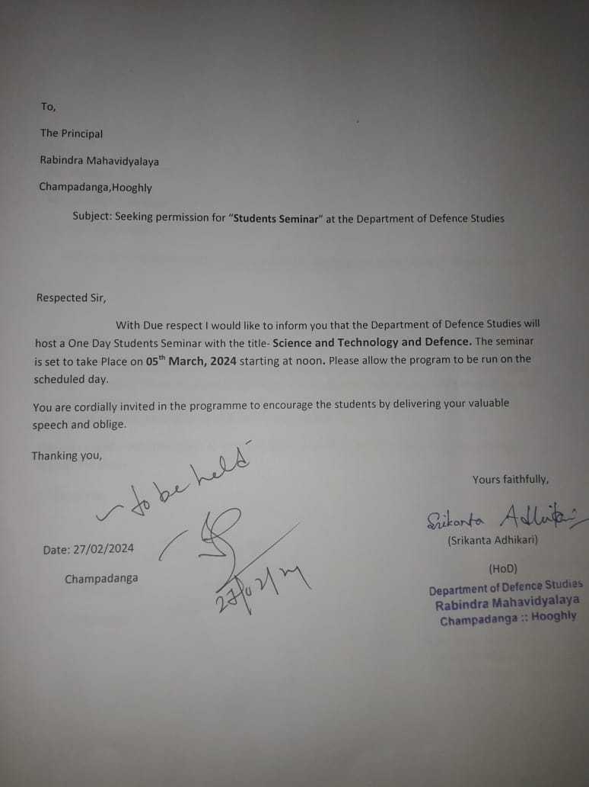

**PHOTO**

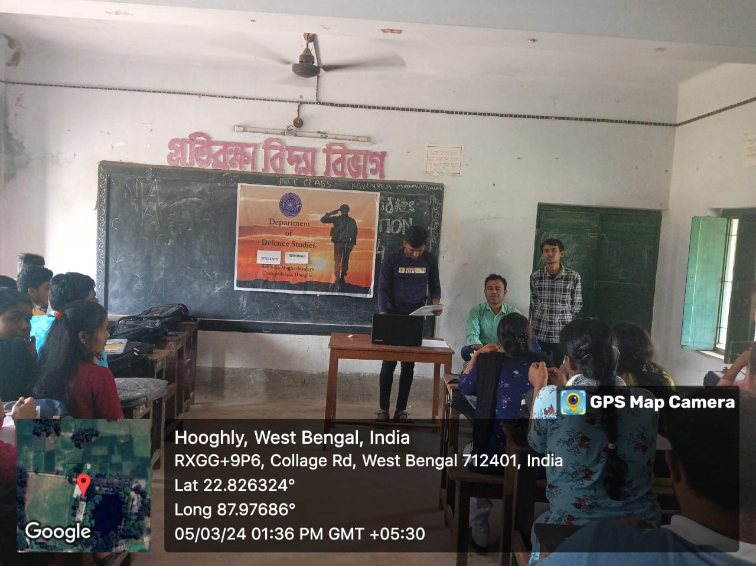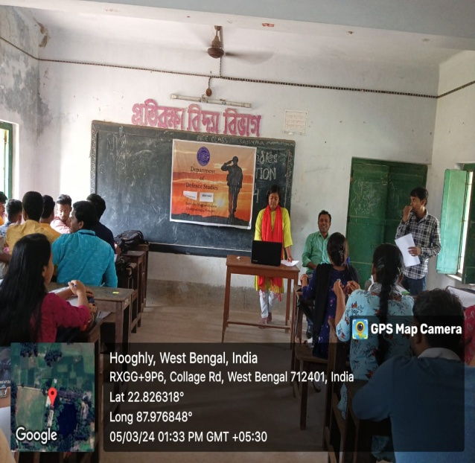

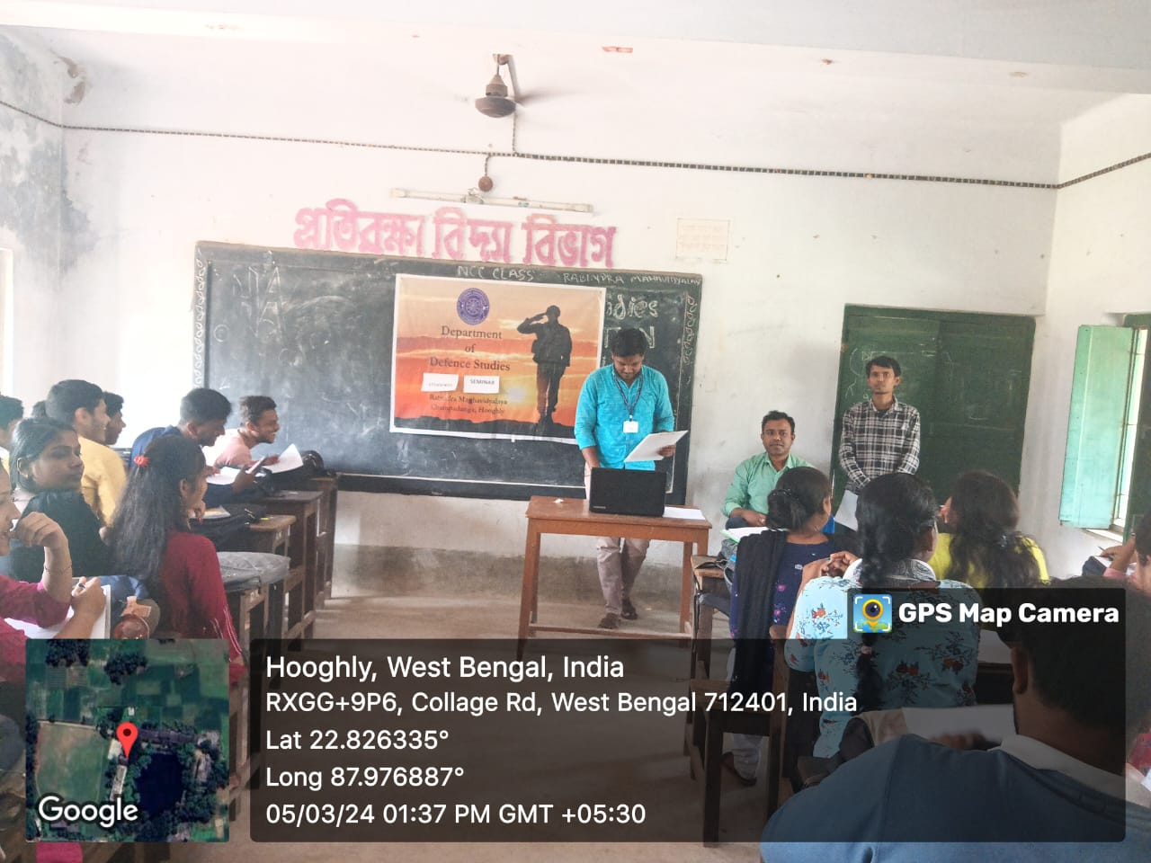

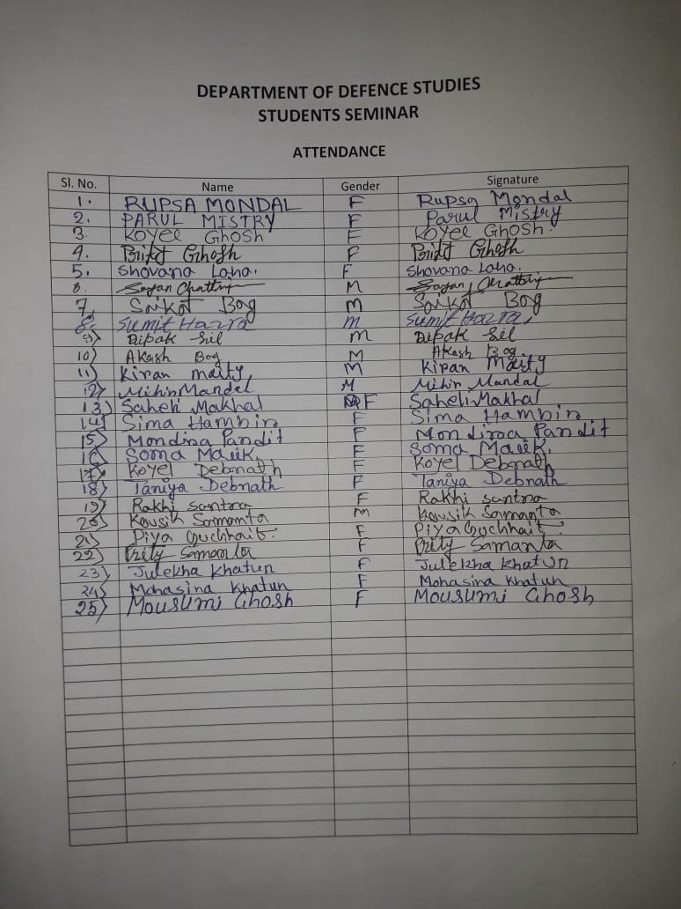

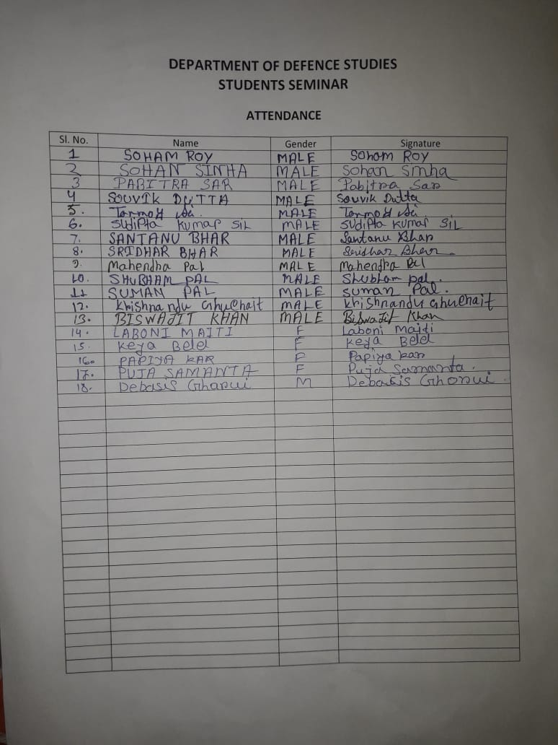

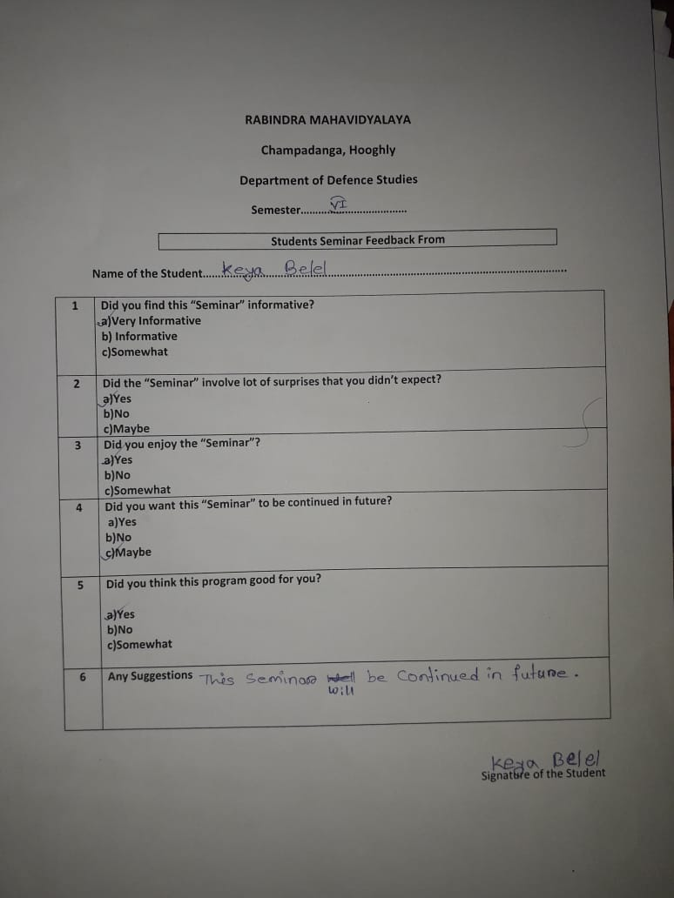

**FEEDBACK ANALYSIS**

**RESPONDENTS (STUDENTS)**

|  |
| --- |
|  |
|  |
|  |
|  |
|  |
|  |

**ACTION TAKEN REPORT**

**Name of the Program: Students Seminars**

**Duration: 5th March, 2024**

|  |  |
| --- | --- |
| **FEEDBACK RECEIVED** | **ACTION TEKEN** |
| Teachers as well as students gave positive feedback. Most of them were of them were happy and satisfied with the event. | It was decided that this event will be continued in future as well. |